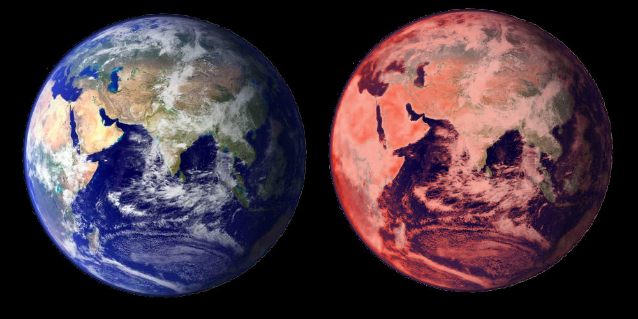
Global warming
Earth will be destroyed during the 21. Century

We need your help!

The Problem: The Solution:





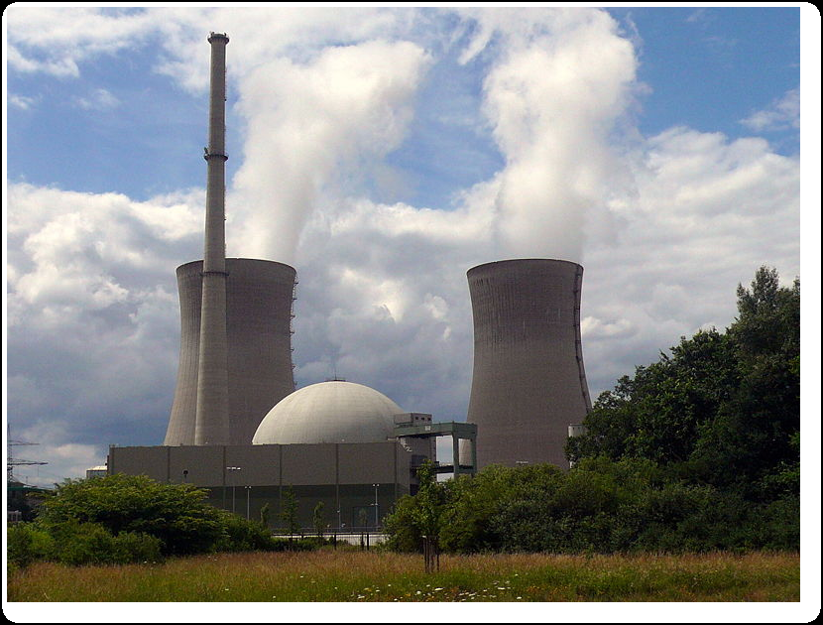
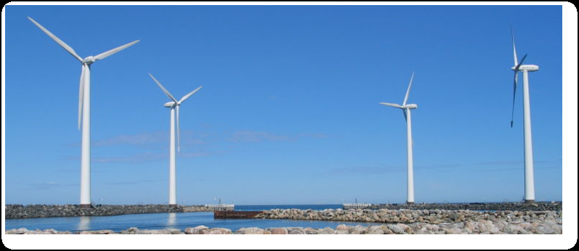

Until 50 years:
- Sea level will rise up to 1,5 meters
- Mass extinction of trees and animals
- Mass movements of people; ghost towns
- Temperature will increase 15° of Fahrenheit

